Predicting Patient Outcomes using Graph Representation Learning

Paper: <https://arxiv.org/pdf/2101.03940.pdf>

Medical data in EHR comes in many formats: text, ICD codes for medicine, procedures and diagnoses. The authors present a new method for considering all these forms of data at once to predict patient outcomes on a graph.

Method: patients are placed in a graph. Their node features consist of temporal features (visit data) and static features. Each of these are embedded separately. The authors use an LSTM and a graph encoder to embed the temporal features and a GNN to embed the static features. The features are then concatenated to create a final embedding.

The LSTM-GNN

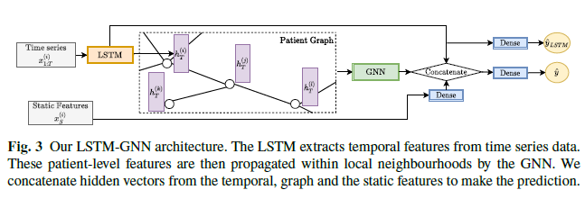

This network architecture essentially performs graph-level embedding on the patient graph.

Results

